**IDEATION PHASE**

**BRAINSTORM&IDEA PRIORITIZATION TEMPLATE**

|  |  |
| --- | --- |
| **Date** | 19 September 2022 |
| **Team ID** | PNT2022TMID40555 |
| **Project Name** | AI based On Emerging Methods For Early Detection Of Forest Fires |
| **Maximum Marks** | 4 Marks |

**Step-1:Team Gathering,Colabrating and Select The Problem Statement**

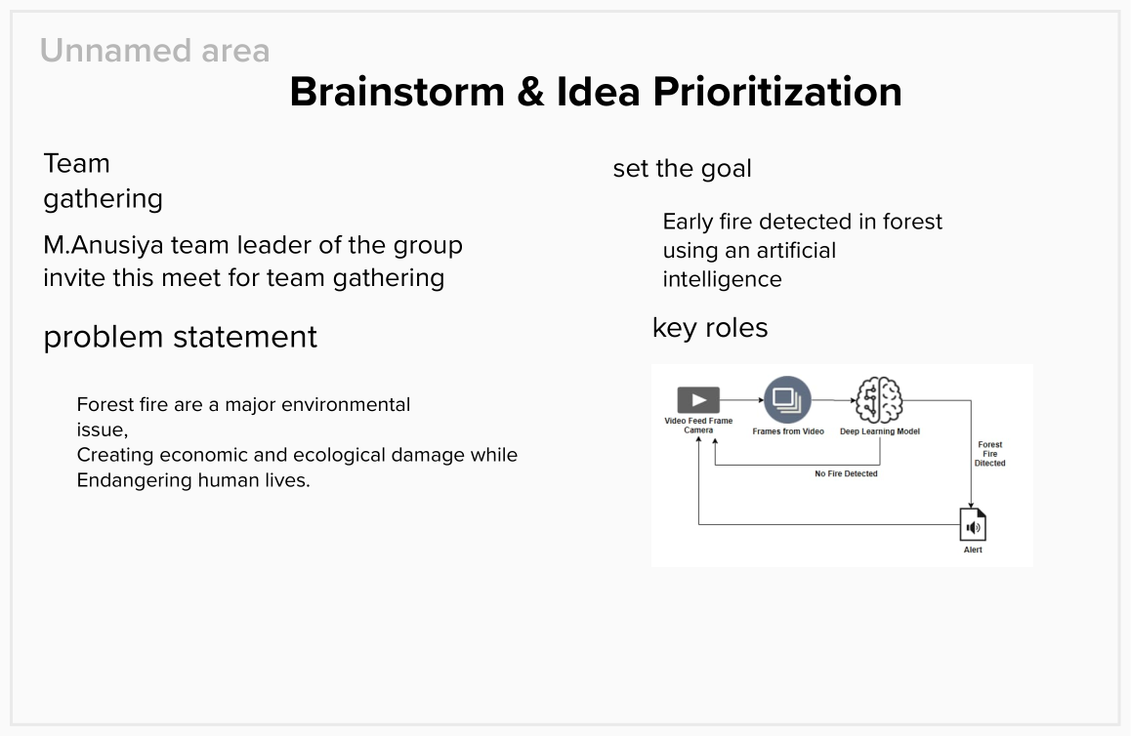

**Step-2: Brainstorm, Idea Listing and Grouping**

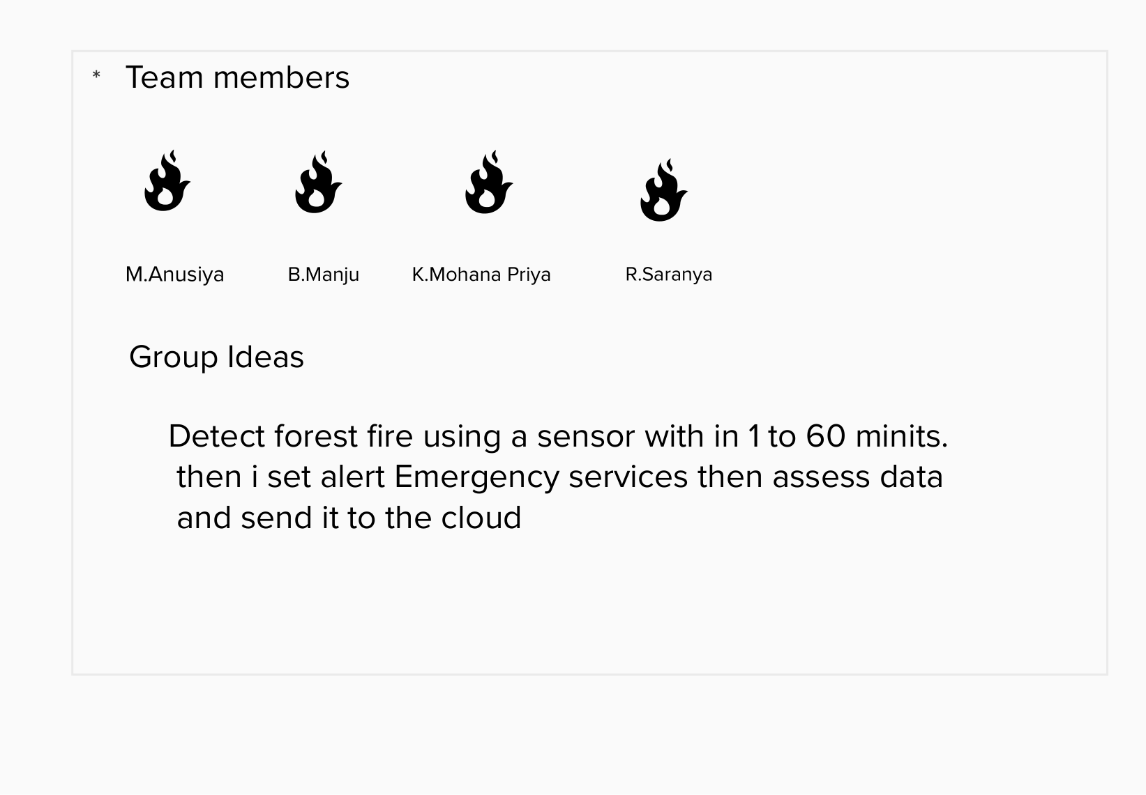

**Step-3: Idea Prioritization**

